BULLSEYE 2!
A rapid redesign implemented after the original concept failed one day before showcase due to a important component's failure.

Project Design Document

1. Design Intent
•What experience are you trying to create?
We are creating an interactive, skill-based laser shooting experience that simulates a real-life shooting range through dynamic difficulty levels and real-time feedback.
•Who is it for?
It is designed for young users seeking an engaging, hands-on alternative to screen based gaming, combining physical interaction with competitive and immersive play.

2. Inspiration & References
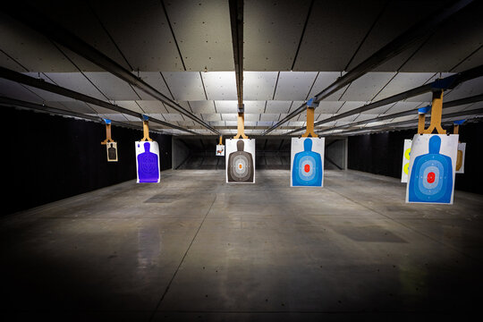
Real life shooting range. With human silhouette targets with varying point system.

3. User Journey
Step-by-step experience of the user:
- User picks up controller from the controller stand. The game starts.
- LCD displays “ READY”, “ STEADY”, “GO!”
- User turns on laser from the controller.
- LCD displays “ Remember the sequence”
- Aims the laser pointer using the joystick of the controller , at the targets that randomly pop up.
- The system uses LDR sensors on the targets to detect the laser. The user must align the laser with the sensor on the target and press the trigger button to shoot. A hit is registered only when both actions occur simultaneously.
- The two targets pop up randomly for eg. First TARGET1 pops up, you hit, then TARGET2, then maybe again TARGET2. The targets pop up a certain number of times in each level randomly. The user must remember the sequence of targets hit. For eg, T1, T2, T2,T2, T1, T2 etc. Each level the number of target appearances increase, hence increasing difficulty as the levels go by.
- The LCD displays “Replicate the sequence” The user must remember the sequence, and replicate it using the controller by pressing button 1 for target 1, button 2 for target 2.
- The sequence points will be displayed on the neopixel ring led for however many numbers are there in the sequence. If the sequence button is right, the certain neopixel led turns green and led strip on the inside turns green. If it’s wrong, neopixel ring flashes red with the led strip too with buzzer sounds indicating the level is over and game is over.
- The score is also determined by the position of trigger hit. If its on the head, it is 5 points. If it’s on the body it is 1 point. The LCD flashes “ HEADSHOT! +5” for headshot, and “SHOT! +1” for body shot.
- Once the game is over. The neopixel ring flashes celebratory colours, LCD displays levels passed and total points and time taken.
- The max number of lights in the neopixel are 16. So, the last level will have the user to remember 16 number sequence.

4. Success Criteria
• Define measurable success:
- A hit is registered only when the LDR sensor detects the laser and the trigger button is pressed simultaneously.
- The system accurately generates and stores the target sequence for each level.
- The user is able to correctly replicate the sequence using the controller inputs.
- The NeoPixel ring correctly represents the sequence length and validates each input step.
- Scoring is accurately calculated based on hit position (head = 5 points, body = 1 point).
- The system successfully progresses through increasing levels, with sequence length increasing up to 16 steps.

• User experience (easy to use, intuitive):
- The system should be easy to understand without external instructions.
- The LCD should clearly guide the user through each stage (start, remember, replicate, result).
- Visual feedback through NeoPixel and LED strip should clearly indicate success (green) and failure (red).
- The buzzer should provide clear auditory cues for hits, misses, and game over.
- The controller interaction (joystick + buttons + trigger) should feel responsive and intuitive.

• Reliability:
- All components (ESP32, sensors, servos, LEDs) should function consistently without lag or failure.
- LDR sensors should reliably detect the laser under different lighting conditions.
- Button inputs (trigger and sequence buttons) should register accurately without false triggers.
- The system should handle continuous gameplay without crashing or resetting unexpectedly.
- Wiring connections should be stable to ensure uninterrupted performance during gameplay.

5. System Overview
- High-level explanation of system

The system is an interactive, skill-based laser shooting game that recreates the experience of a shooting range combined with pattern recognition and memory-based gameplay. It uses a combination of physical interaction, sensor-based detection, and real-time feedback to engage the user.

The controller joystick is connected to the ESP32 via Bluetooth. The joystick’s X and Y axis movements are mapped to two servo motors mounted together, which control the direction of a laser pointer fixed on top. This allows the user to aim the laser in real time by physically moving the joystick.

Targets pop up at random intervals and positions, and the user must aim and shoot using the laser and trigger mechanism. At the same time, the system generates a sequence based on the order in which targets appear, which the user must observe and remember.

A hit is registered only when the laser is aligned with the sensor on the target and the trigger is pressed simultaneously, ensuring intentional and precise interaction. The system differentiates between headshots and body shots using separate sensors, assigning different point values to each.

After a sequence is completed, the user is required to replicate it using input buttons on the controller. The system validates the sequence and provides immediate feedback through the NeoPixel ring, LED strip, buzzer, and LCD display.

As the game progresses, the sequence length increases, making it more challenging and testing both the user’s reaction time and memory. At the end of the game, the system displays the user’s performance, including score, levels cleared, and time taken, before resetting for the next round.

- What are the main parts?

1. Controller Unit
• 1 Joystick — used to control the aiming direction via servos (X and Y axes)
• 2 Push Buttons (Button1 & Button2) — used to replicate the sequence (Target 1 and Target 2)
• 1 IR Sensor — detects the presence of the controller

2. Laser Aiming Mechanism
• 1 Laser Module — emits the laser beam
• 2 Servo Motors — control movement:
o One for horizontal (X-axis) rotation
o One for vertical (Y-axis) rotation

3. Target Units (x2)
• 1 Servo Motor (each) — controls pop-up and drop-down motion of the targets
• LDR Sensors on each target — detect the laser:
o 1 Head LDR (5mm) — detects headshots (5 points)
o 1 Body LDR (12mm) — detects body shots (1 point)

4. Feedback & Output Components
• 1 NeoPixel Ring (16 LEDs) — displays sequence, feedback, and game status
•2 LED Strips — provides additional visual feedback
• 1 LCD Display — shows instructions, sequence prompts, and score
• 1 Buzzer — provides auditory feedback (hit, miss, game over)

5. Microcontroller & Communication
• 2 ESP32 — processes inputs, controls outputs, and runs the game logic
• Bluetooth (inbuilt in ESP32) — connects the controller joystick wirelessly to the system

9. Circuit Diagram
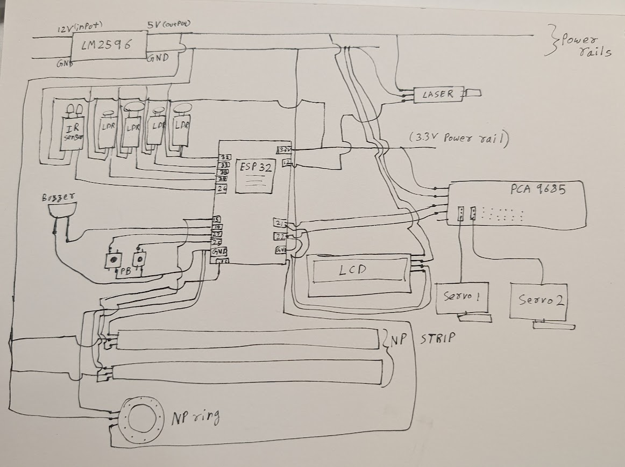

10. New iteration (Again) due to component failure
During development, the original plan involved using servo-driven targets that would physically pop up in sequence. However, due to reliability issues with the component, the mechanism did not perform consistently. Rather than presenting a non-functional feature, the system was reworked to ensure a stable and complete gameplay experience.
In the revised approach, the targets remain constantly visible, and the LCD displays a specific sequence that the user must follow. The player aims the laser and shoots the targets in the given order, with each successful hit contributing to the sequence they must remember. After completing the shooting phase, the system prompts the user to replicate the sequence using input buttons. Immediate feedback is provided through NeoPixel LEDs, the LCD display, and a buzzer, maintaining engagement while preserving the core challenge of precision and memory.

